AWS server migration service (SMS) - Episode-01

How we can migrate our on-premises virtual machines to AWS using server migration service(SMS).

There are other methods are also available to migrate the VMs to AWS.

for example: export import , use snowball etc. …

here we are going to use the SMS connector for VM server migration to AWS

**What is SMS**

1. It's a service which automates the migration over on-premises VMware vSphere or Microsoft hyper-v machines to AWS cloud.

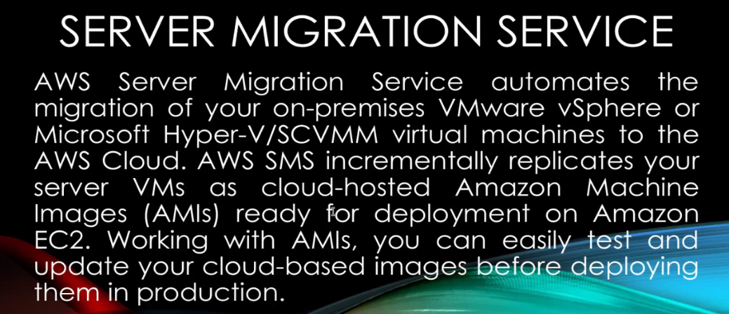

1. It also incremental replicates the server VMs to Amazon images and you can use them and deploy them to Ec2 machines.
2. Whatever you are you know running or in your existing virtual machines in your on-premises data center it will take the snapshot of the existing machine and migrate create the AMI and you can use that ami to start the ec2 machine.

I have created a one smaller diagram and which depicts the on-premises data centers and how we're going to migrate the vm's to our AWS. 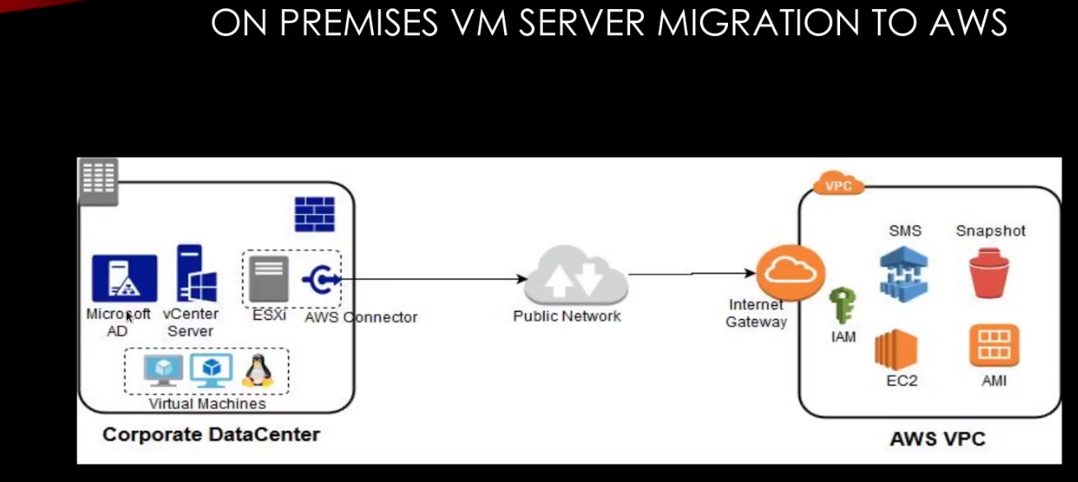

This is our corporate data center where you know I have hosted the virtual machines… 2 Windows machines and 1 Linux machine.

1. I have created two machines… one machine is for Microsoft AD and one machine for vCenter server and this is VMware ESXi …you can use hyper-v as well.. If you are using Windows.But I am using the ESXi .
2. On ESXI machines I have imported AWS connector… I will show you how to download ESXi vCenter machines and how to configure the Microsoft AD and how to upload the AWS connector.
3. In this lab, I am NOT going to create all these machines... I will just create only linux machine we will migrate that machines to our AWS cloud.
4. To connect your on-premises network to a public network, you should have access to the Internet. For security reasons, in corporate you know you have a firewall installed.So it won't allow you to directly access the net . You can also able to configure Web proxy.

but here I am NOT going to do that.. I have directly using the connectivity from ESXI to my public network and that public network will connect to Internet gateway of AWS.

1. To configure AWS, you need a one user and one role that is called **IAM user and role**.. You have server migration services available on AWS console or you can use AWS CLI.

4.) SMS basically takes a snapshot of the VMS and store it into AWS and then those snapshot will you convert it to AMI and then EMI is converted use those AMI to use the ec2 instance.

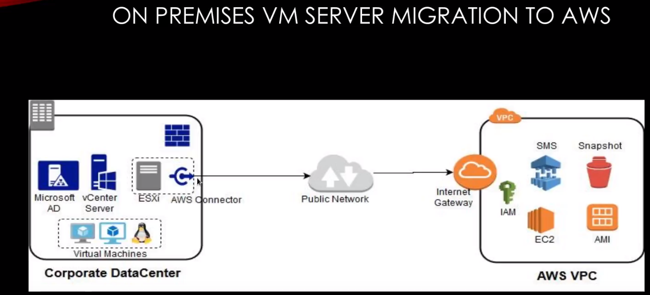

I'm going to use the AWS default VPC but if you have you can you know configure it you're on private VPC as well..

I am using public network so you know it might take some time to upload the OPF files to ESXi or software to sxi so I'm going to pause my video in between ok and even a vCenter installation

Most of the companies they also get the direct connector connections to your data center as well so that you have a more bandwidth to transfer all your own VMs to AWS. Usually public network is not that much feasible especially for me because I'm using my home my internet Wi-Fi ok so you can use the direct connect as well but to get the direct connector it might take months to year as well… to set up the dedicated line to your on-premises.

**Start this lab:**

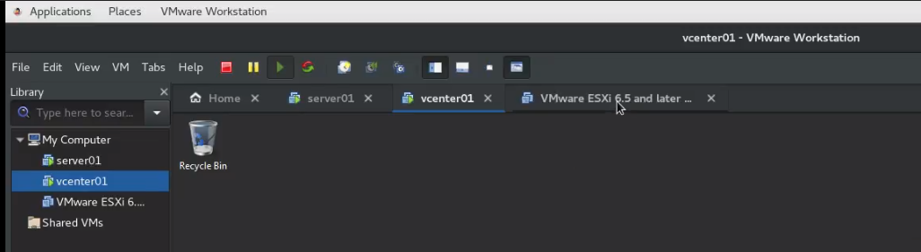

I have already created VMware vCenter on my VMware client on my Linux machine… and then I have created a two windows 2012 servers installed it.

I have also imported ESXI machine.

I'm going to use all these machines for the migration purpose…

To download VMware vCenter -🡪vmware.com🡪login🡪downloads 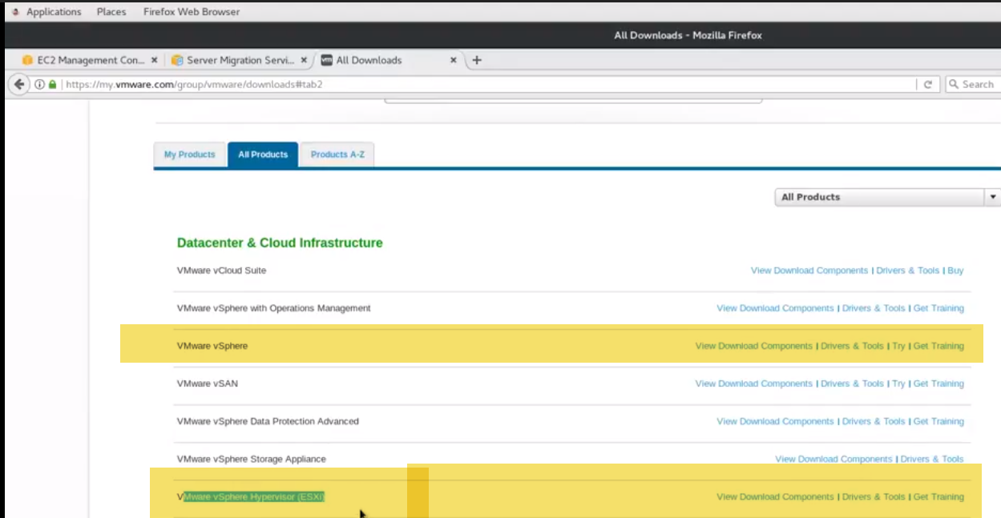

you can use the trial software.

Agenda for this lab:

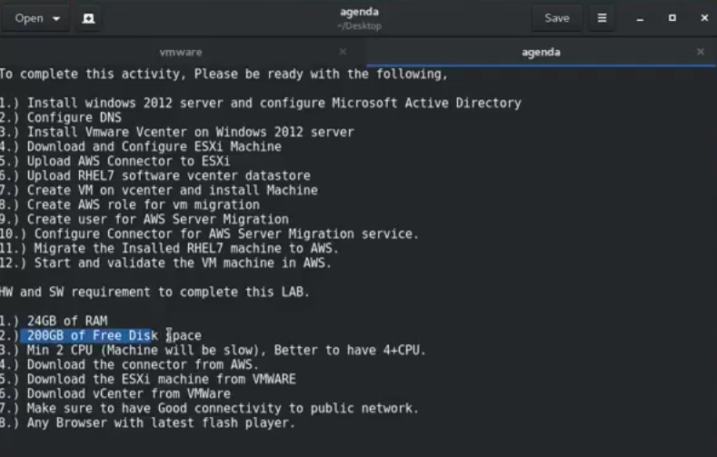

**To download that SMS connector:**

go to server migration service… 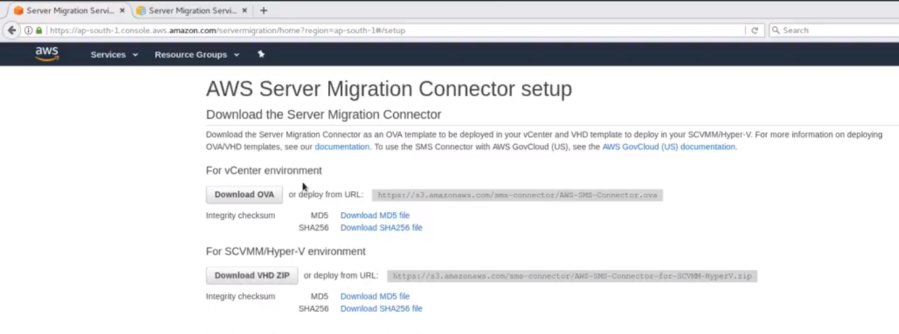

download the either OVA or VHD zip file…

I'm using V Center -🡪downloaded ova..

1. first configure our windows AD and then we will configure DNS and DHCP is you can also configure what I am not going to use that DHCP it's optional…but make sure you always assign the static IP to the V Center okay after DNS we will go and configure the vCenter and then we will use our Esxi appliances and then finally we will host our machine into AWS console…
2. Microsoft Active Directory basically provides access and authorization service.

AD is not mandatory basically what I am simulating our own premises data center where you have AD and all other servers which users are in ad and the computers are in AD and you can access them.

But it's not mandatory.. you can just directly go and install VCenter and ESXi machine and you can use them as well to migrate machines to the AWS cloud.

a.)To configure the Microsoft AD -🡪 just open the server -🡪 computer name is something different 🡪give good naming convention to this machine….like like server 01.-->restart later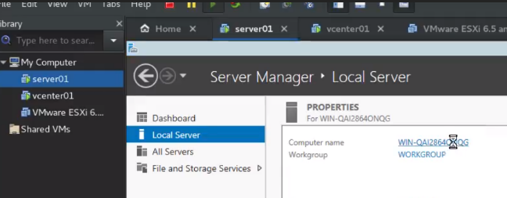 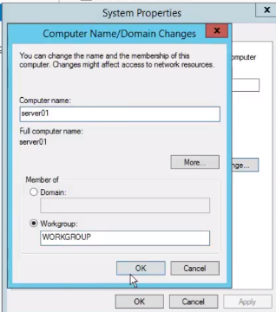

b.)assign some static IP to AD machine.

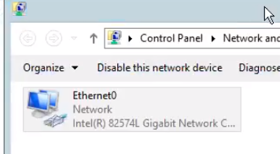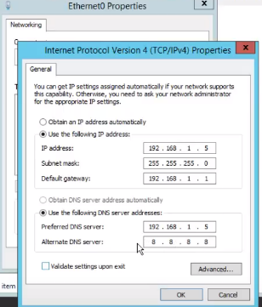

c.)On 2nd machine also…Do same. Name: vcenter01. 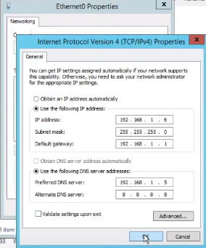 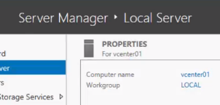

reboot

d.) verify: 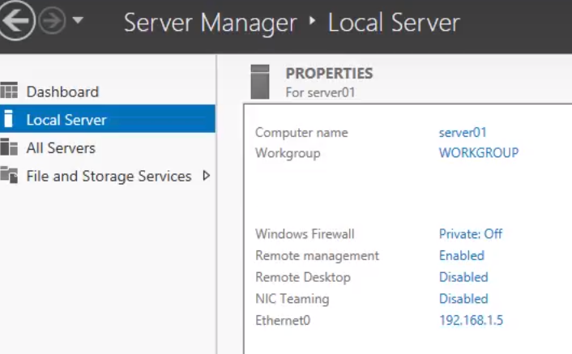

computer name still showing as work group only… it's not connected to any domain controller.

What we will do to configure Microsoft AD on this machine …

manage -🡪add roles and features.

so whatever you can use you can just go hit over at role and features next role-based select next just letter Active Directory domain services yes and DNS I'm not going to install th see me what I'm not using it okay next next next next install so this will take some while so let's wait for this to finish and we will come back once that is done meanwhile I am going to pause the video so now you can see installation is done okay when C configuration required installation succeed you just go and hit close okay so once that is done okay just you need to go to this flag click here and you can see promote this server as a domain controller just click on it okay so now you can see there are three options add a controller to existing domain I don't have so this option is not valid for me I had a new domain to an existing forest that is also not valid because I don't have any existing forest so add a new forest just click here and give some domain name so I'm going to give you clear sis dot-com because you can give anything I am giving this is calm because this is my registered domain give next ok and this you can see a functional level and domain function level so if you want to know previous support of Window Server you can just go and select the older version as well and here you can see this password is required if you you know I want to do perform some restore of the services so please remember this password take some time because I have given only to levy of memory and any one CPU so it may take some time we have to wait okay it's game so you can see here you have older version 2008 and release - okay so you can use that and you can give some good password here and click Next and it's okay click Next and you have to give my NetBIOS name okay so you can use whatever you like by default it will take your Eclair sis in caps so I'm going to give as a lab and in your corporate you don't have to you know reconfigure this because it's already configured Y or Windows admin so this is database folder and log file location I am NOT going to change keep it as it is okay now you can adjust your selection give next now it will give us some really Christy check if anything is missing you have to fix them before going ahead so this may take few minutes or seconds so just wait okay so you can see all pretty quick checks pass click install to begin so you can see successfully so just hit install okay so this is going to take some time so I will just go and pause that we do here once installation is done we will come back so now you can see installation is done and it will be start our machine so that machine is restarting currently so that the machine will come back okay just to remember I'm going to you know create this lab in three different stages because the beauty of this land will be little longer so I don't want all the my audience has to know go through all the steps if they are not valid for them so I will upload this video in parts like 81 and we Center and then yes X I okay so we Center and yes si you can see in collaboration but I will have a separate video for Migration Service so whatever valid you can look into it and I will also create a one full video so if you are no B you can just go from start to end okay so our machine is now coming back so it takes some time to tow all the configuration so just to wait for few more seconds two minute so let me pause the video so now you can see machine is ready and it's giving logging so just two you can see it's lab administration type the password I logged in into my machine that's wait for few seconds to start the server manager so server manager is coming up meanwhile let's see go to local computer ok now you can see my domain name is reflecting here instead of workgroup now through waiting as a domain and you can see like it's a clear says calm ok so just minimize this so we have created a ad now what we have to do we have to just go and configure our DNS to configure the DNS just go to tools and DNS ok now you can see I have a forward look up zone time reverse lookup John so if you click expand the forward look up zone you can see Claire says calm and you can see this machine is already a part of domain but you can see they were slow kept John there is nothing so what you have to do just go and right-click new zone next select the primary zone next all DNS server I'm going to use for ok so here to keep the network ID so 192 168 not one in you can see it's automatically taking there he was broke up John default finish ok so this is now go back and double click right click and update the pointer okay yeah you can see 192 168 1.5 wings added now I'm going to add we sent our machines to this domain so what we have to do you can directly add or you can just go and add new hosts and given visas and 0 1 and IP addresses 192 168 1.6 192 168 1.6 at host ok done double click update the pointer default refresh now go to V Center and connect to this machine ok one more thing to remember make sure you know you can switch off the firewall so you can see turn off the firewall turn off ok otherwise you have to open the specific ports so same here just go right click firewall dot CPA like already switched it off yes so close this ok to add the vCenter into our domain just click on local server and click on local one minute let's worried I'd be fast ipconfig well it's not taken correct IP back I peel it 1.6 or 92 correct only oh it's not reflecting it's not renewed IP address yet okay let's see try we'll fix this letter if it's not working so just go hit here change connect to clear space usually I usually aru versus dot-com oops could not be contacted Bing 192 168 1 okay I think I need to fix this IP address first there it seems to be some Network change adapter No okay let me fix this make sure first then we will continue from there okay thanks guys